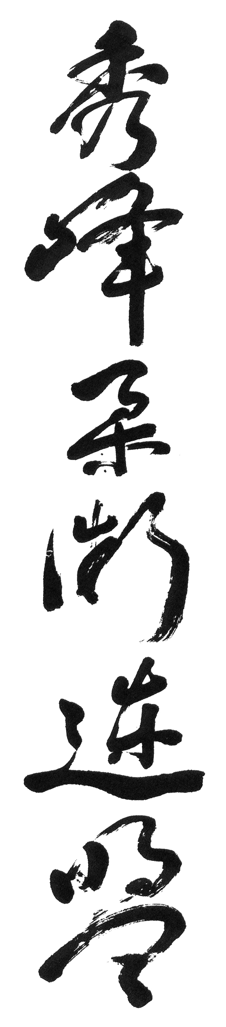
Purple Belt (3rd Kyu)

Valley Drop (2)

Counters to Straight Arm Lock (2)

Counters to Back Arm and Collar Hold (4)

Counters to Bar Chokes (3)

Head Hip Knee

Wedge Blocks (2)

Shoulder Wheels (2)

Locking Techniques Standing and on the Ground (15)

Freestyle Knife Blocking

Defence Against Kicking Techniques (8)

Kumite

Randori

